WIZARD L
ZN LINE

BUILDING INSTRUCTIONS
V.1

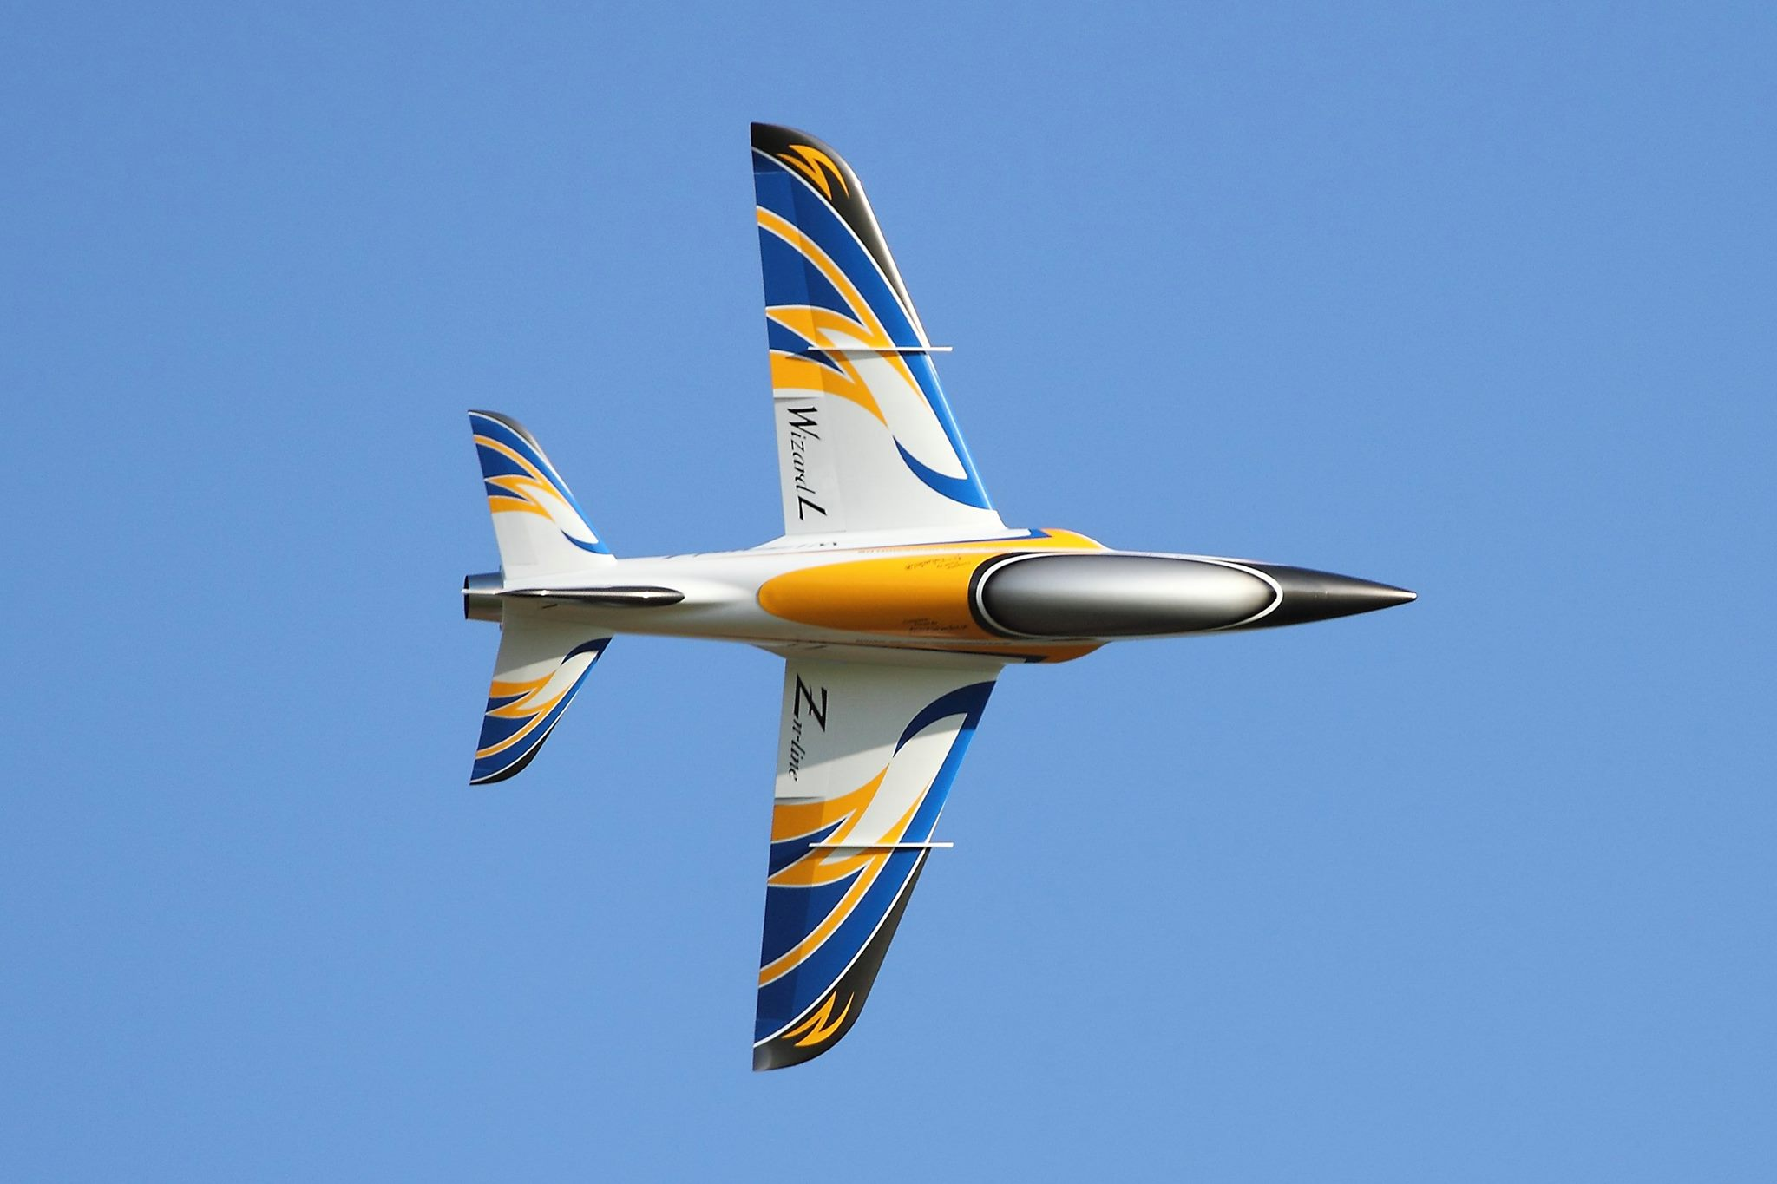

SPAN: 2.86m
LENGTH: 2.98m
WEIGHT : 19kgs
ENGINE : 160-220N

STANDARD KIT

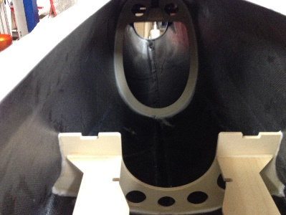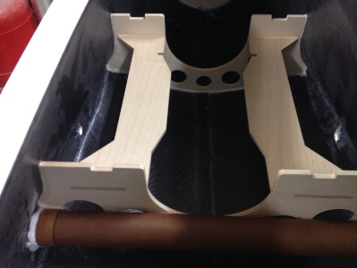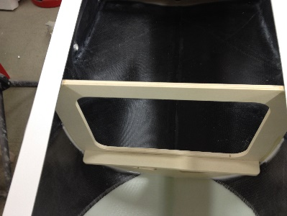

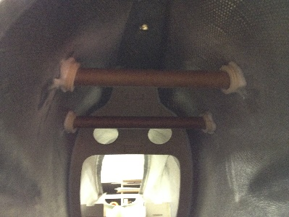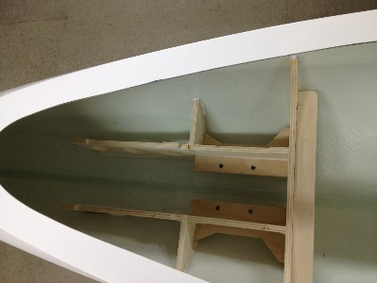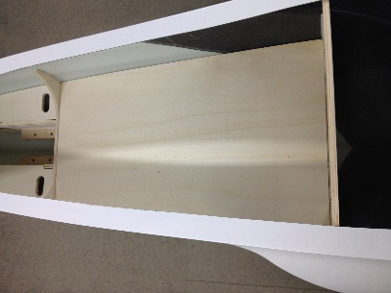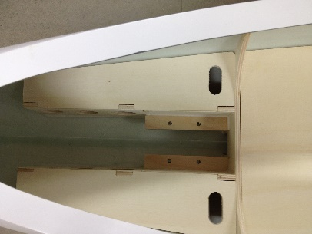

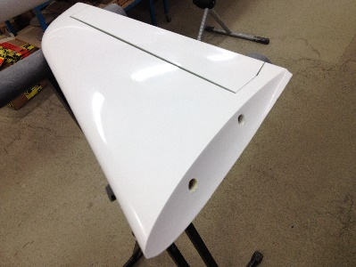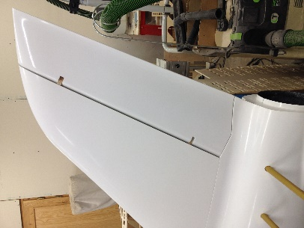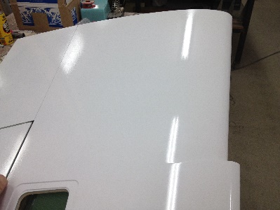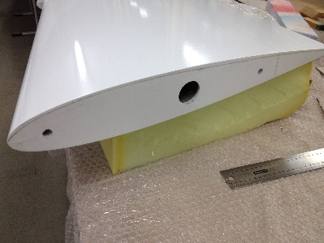

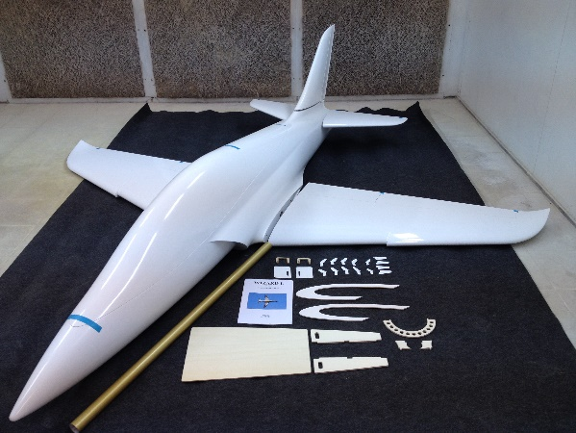

STEP 1

Open the all glass fiber parts like pictures with or without glass canopy (option)

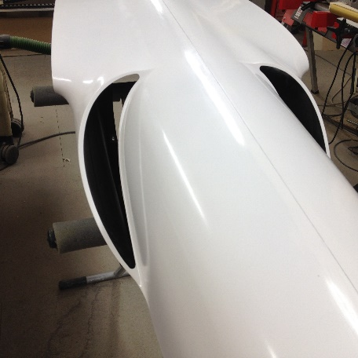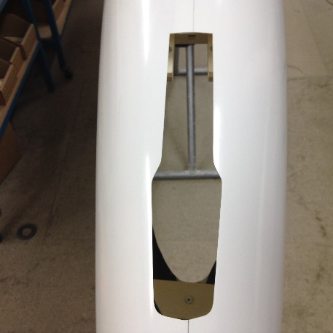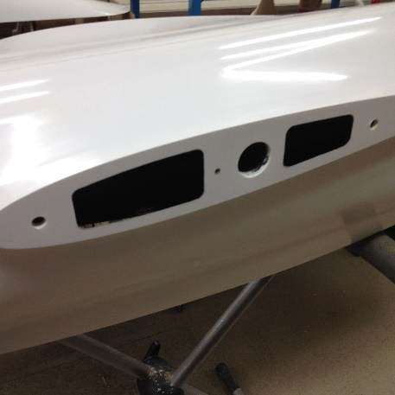

Air Intake – Nose gear- Fuselage Karman

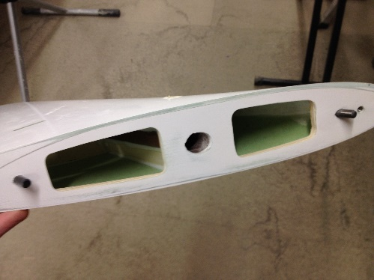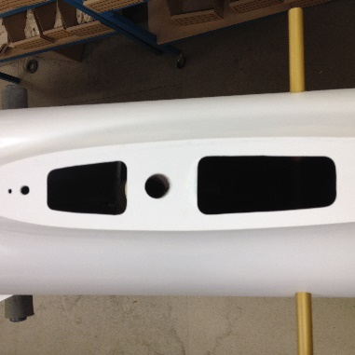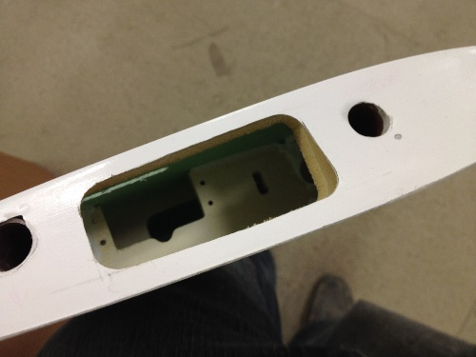

Rudder- Rudder Karman- Stab root

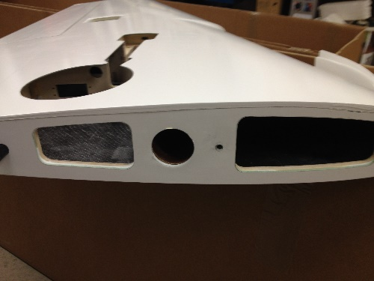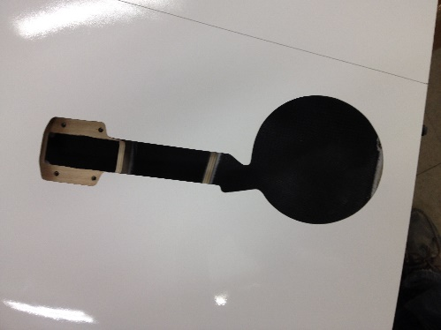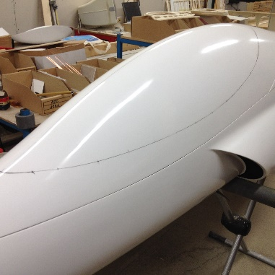

Wing Root- Wing Main gear- Glass canopy (Option)

STEP 2 (step 1 +)

Canopy installation

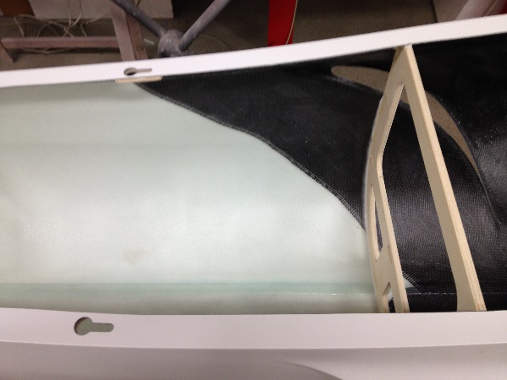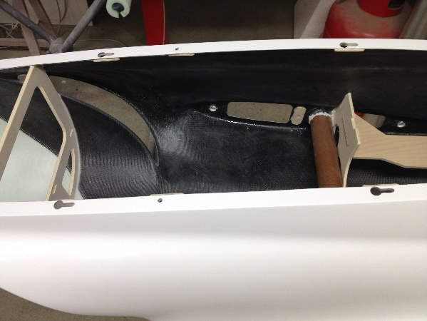

The canopy installation need a certain time and patience. You have to glue the 8 plywood parts to the correct position.On the left picture ,the distance is 240mm between the center of the big hole and the center of the vertical plywood. On the right picture, the distance is 105mm (center hole)for the first and 460mm for the second one also from the vertical plywood.The 2 additional holes are to secure in place the rear canopy.Now ,adjust the plywood for the rear canopy ( photo below) and glue in place after adjusting the glassfiber on the fuselage, in the same time you can insert epoxy verticaly in the front canopy for the later 4mm screw.After 24h ( depending what epoxy is used)you can mill the 6 holes and make sure that the M5 plastic screw ( includes) are fitting without play. Install now the front and rear canopy frame to the fuselage and when you have the right position, you can secure with tape into the fuse. Make a hole to the front trough the canopy and fuse and glue the plywood with the 4mm mpjet. When epoxy is dry, you can remove the front canopy and finish the rear canopy first. With a small pen , mark the contour of the 4 holes and drill a 5mm hole on the canopy frame at the end of the big hole.Make sure about the canopy frame is perfectly aligned with the fuselage before to glue the 4 plywood parts.Use some wax or sticker to make sure it is easy to unscrew when epoxy is dry.after 24h, remove the rear canopy and install the front with the 4 screw, do the same work with a pen and glue the 2 plywood . this operation is a bit difficult due the distance to glue the plywood parts. Is easy when you have the glass canopy option, because the frame is open at this place.You can now make the last 2 holes to secure the rear canopy frame and glue the 2 plywood with 2 M5 plastic screws.

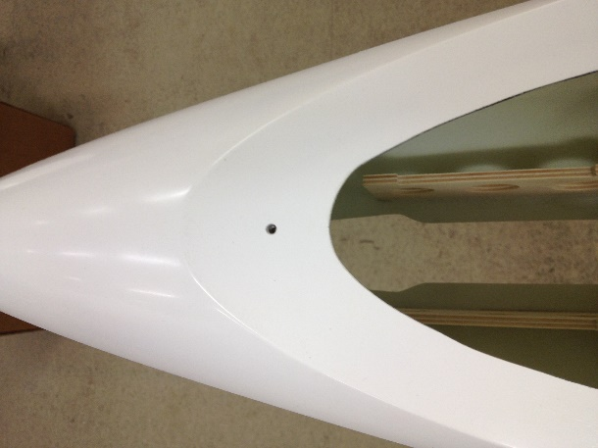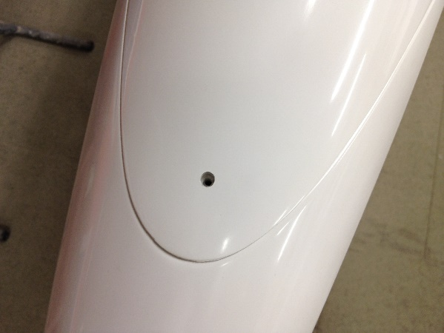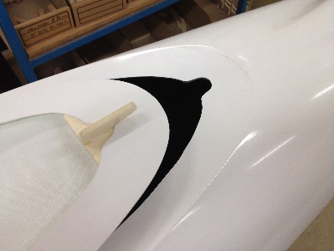
Canopy M3 screw

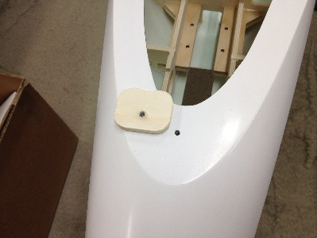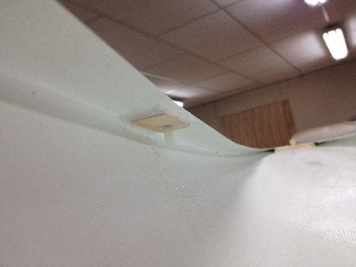
2 last holes with M5 screw

Wing, Stab, Rudder screws.

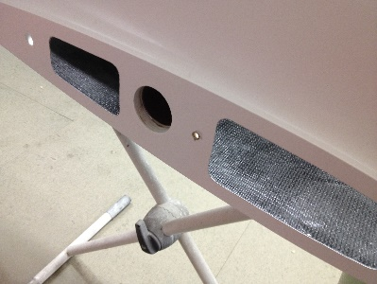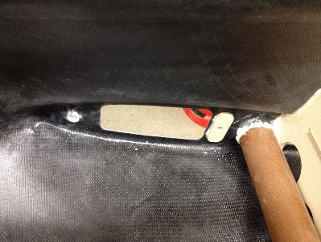

Wing M6

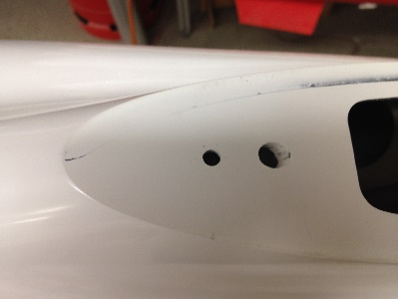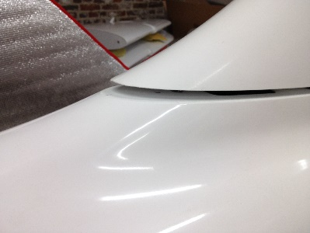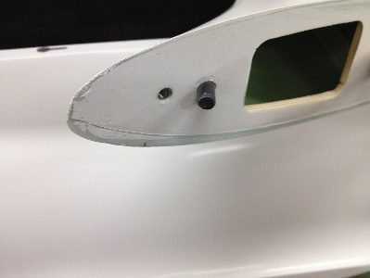

Rudder M4

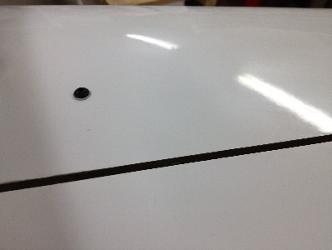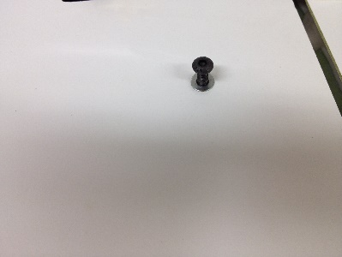

Stab M4

STEP 3 (step 1+2)

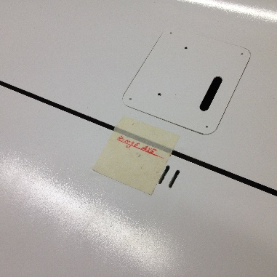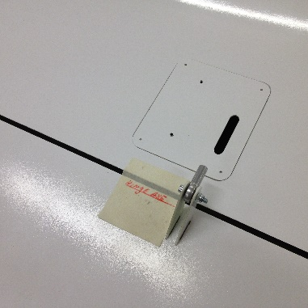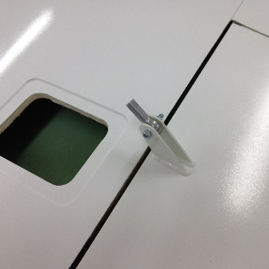

Wing Control horn with ball link

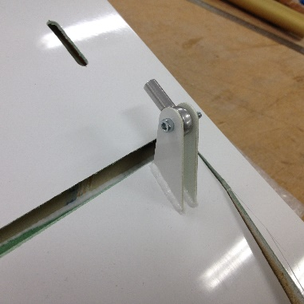

Stab with control horn and ball link

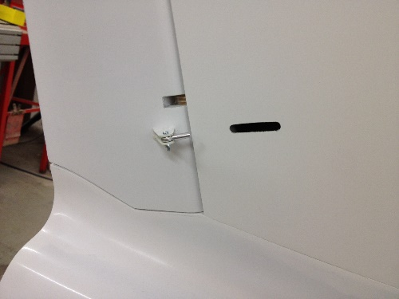

Rudder with control horn and ball link

TANK INSTALLATION

INSTALLED IN THE PLANE (If ordered) WHEN STEP 3

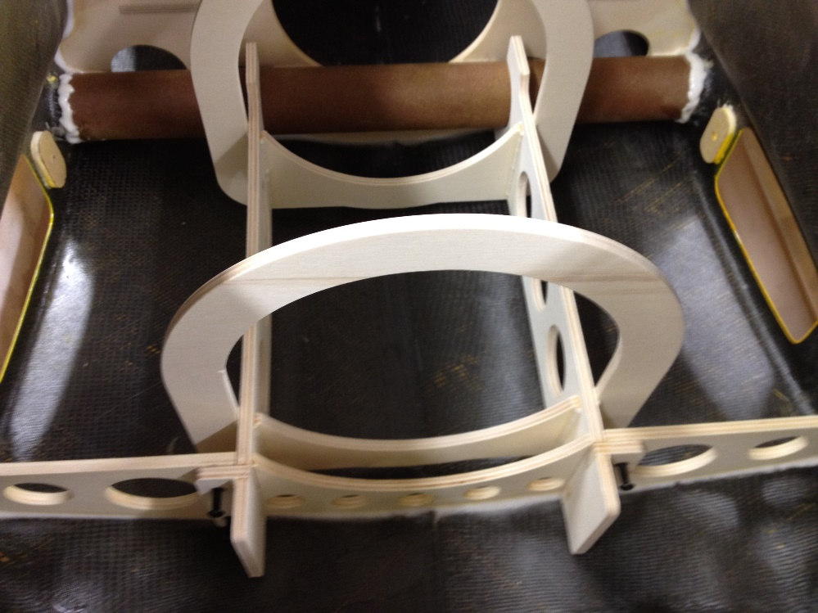

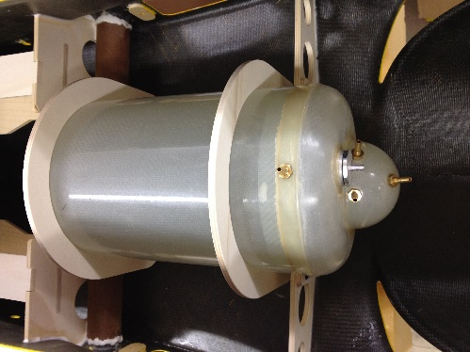

The tank is an option

AFTER STEP 3

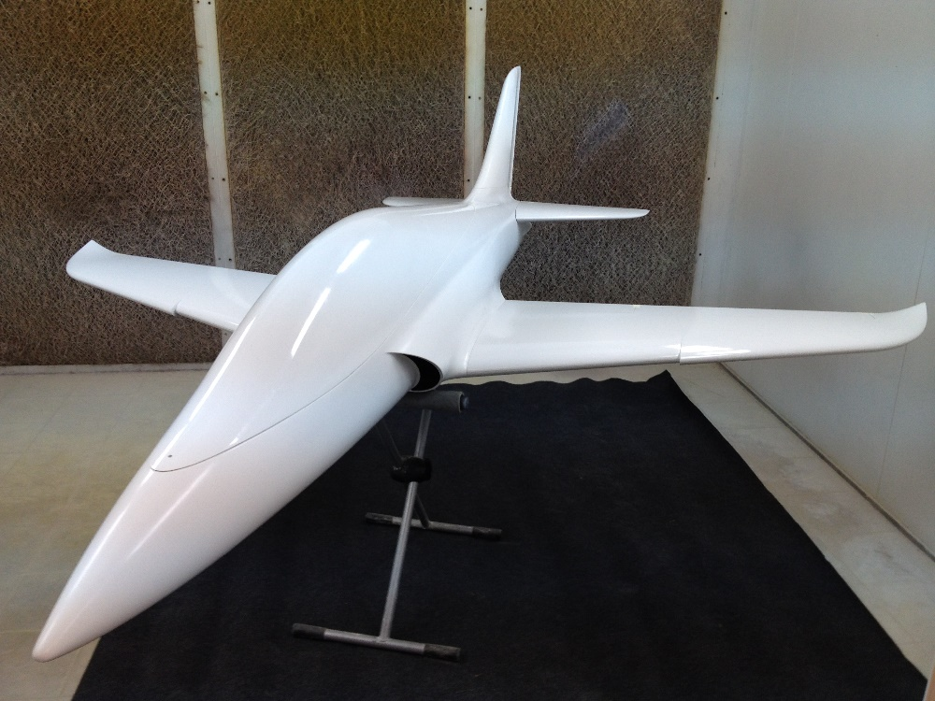

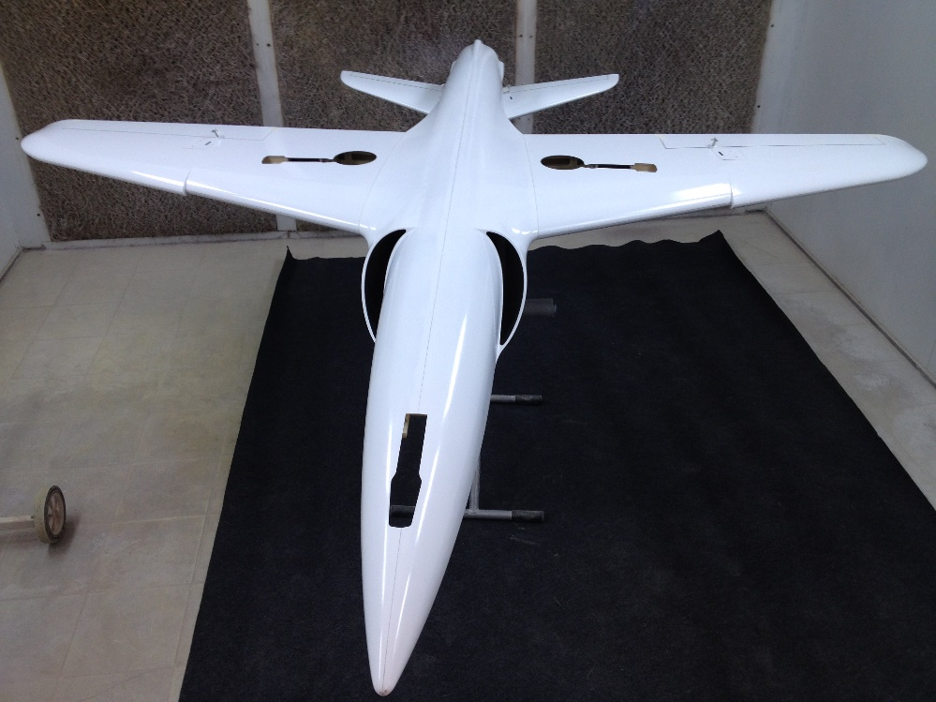

OPTIONS

Tank

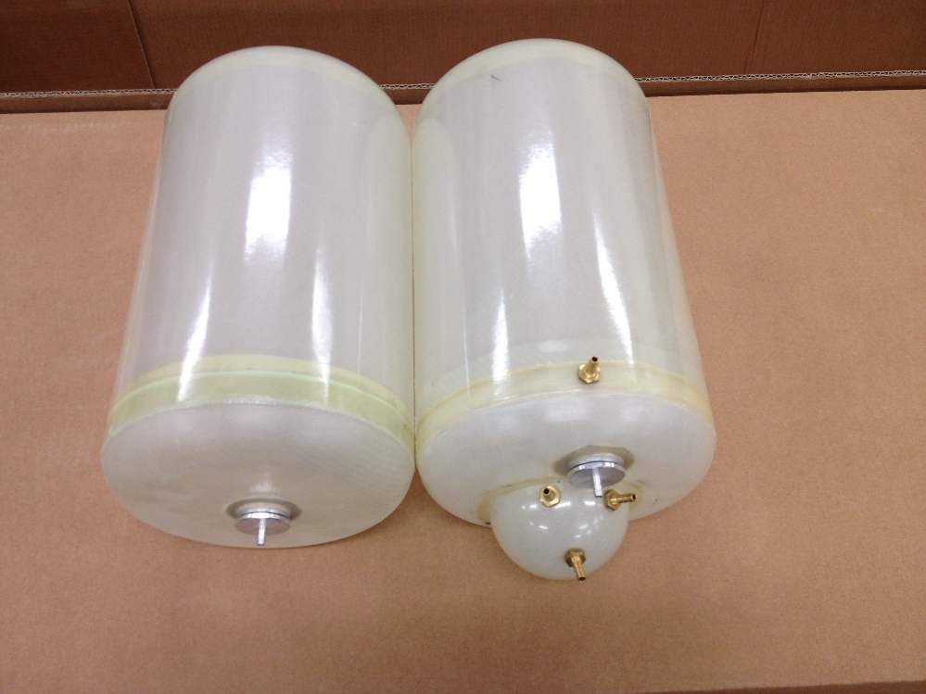

5.6L with or without UAT

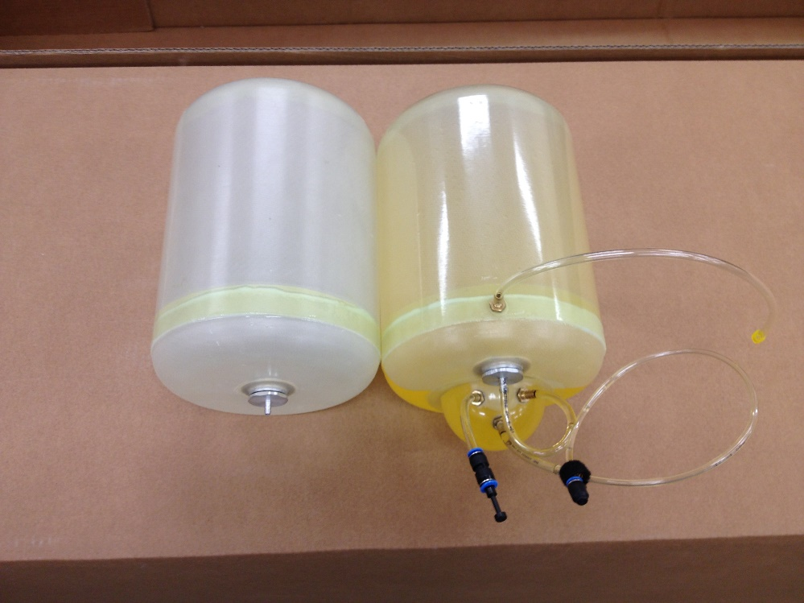

4.6L with or without UAT

Pipes

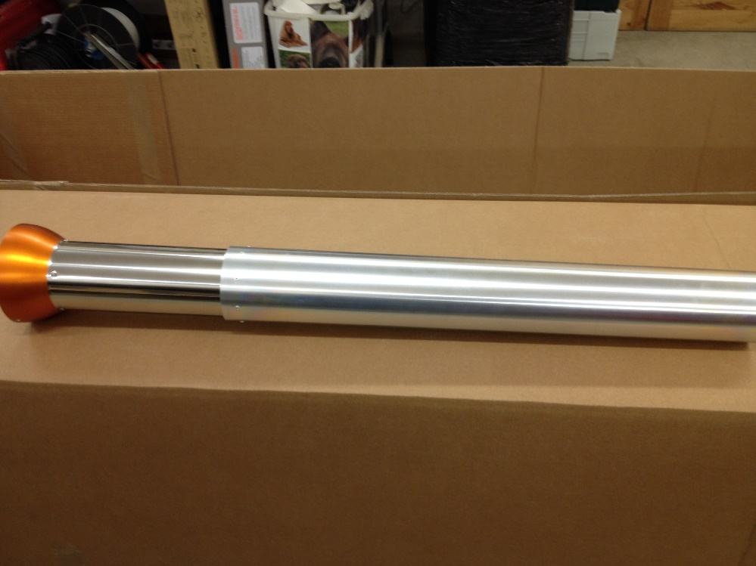

Standard

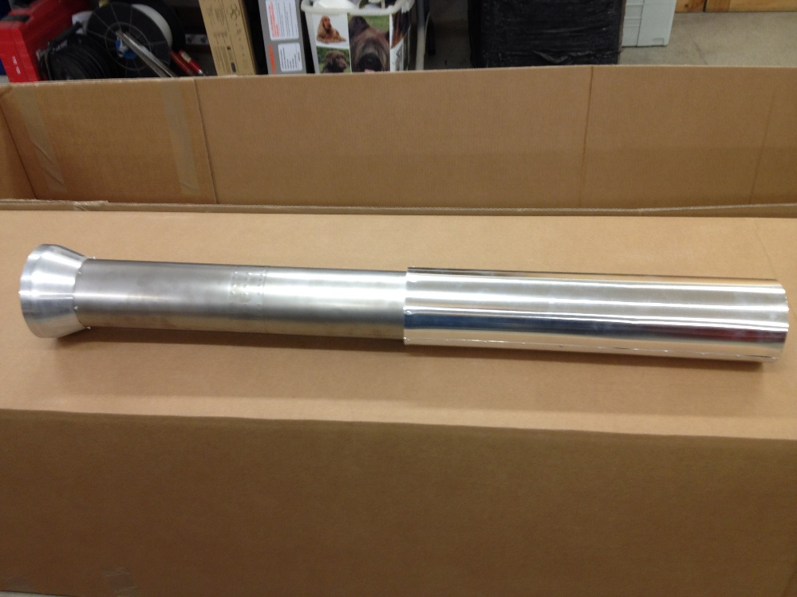

Titanium

E-GEAR

INSTALLED IN THE PLANE (If ordered) WHEN STEP 3

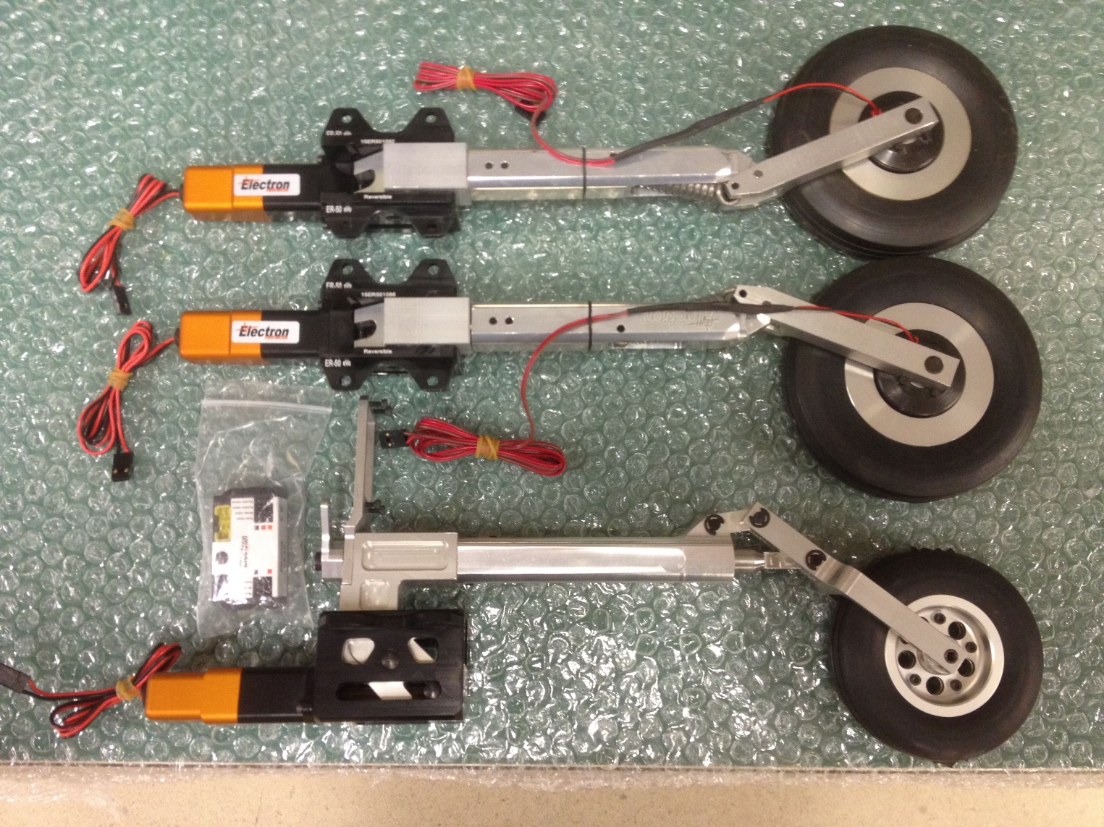

Electron E-Gear-Brakes

COVERS

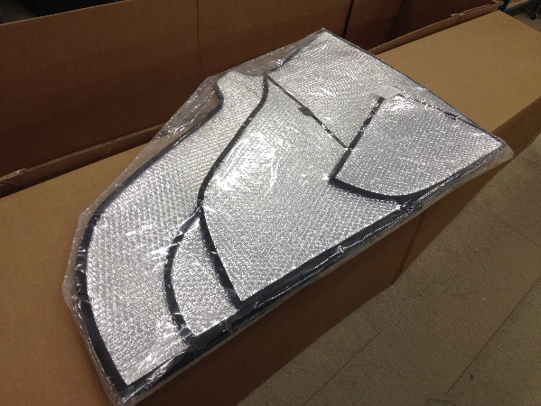

Standard

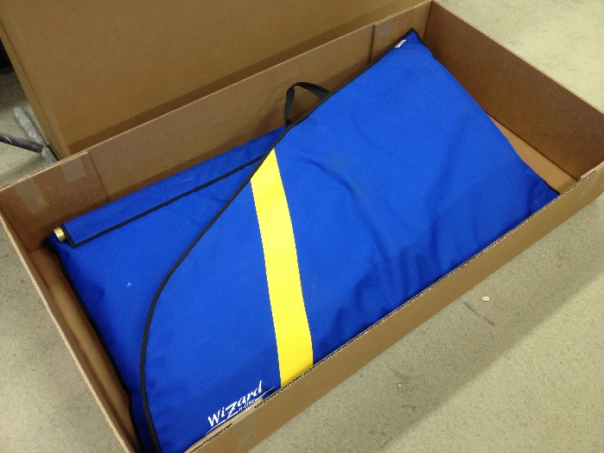

Deluxe

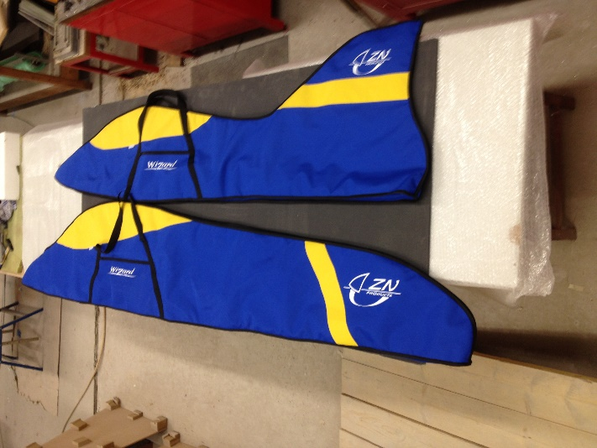

Deluxe

ELECTRONICS INSTALLATION SAMPLE

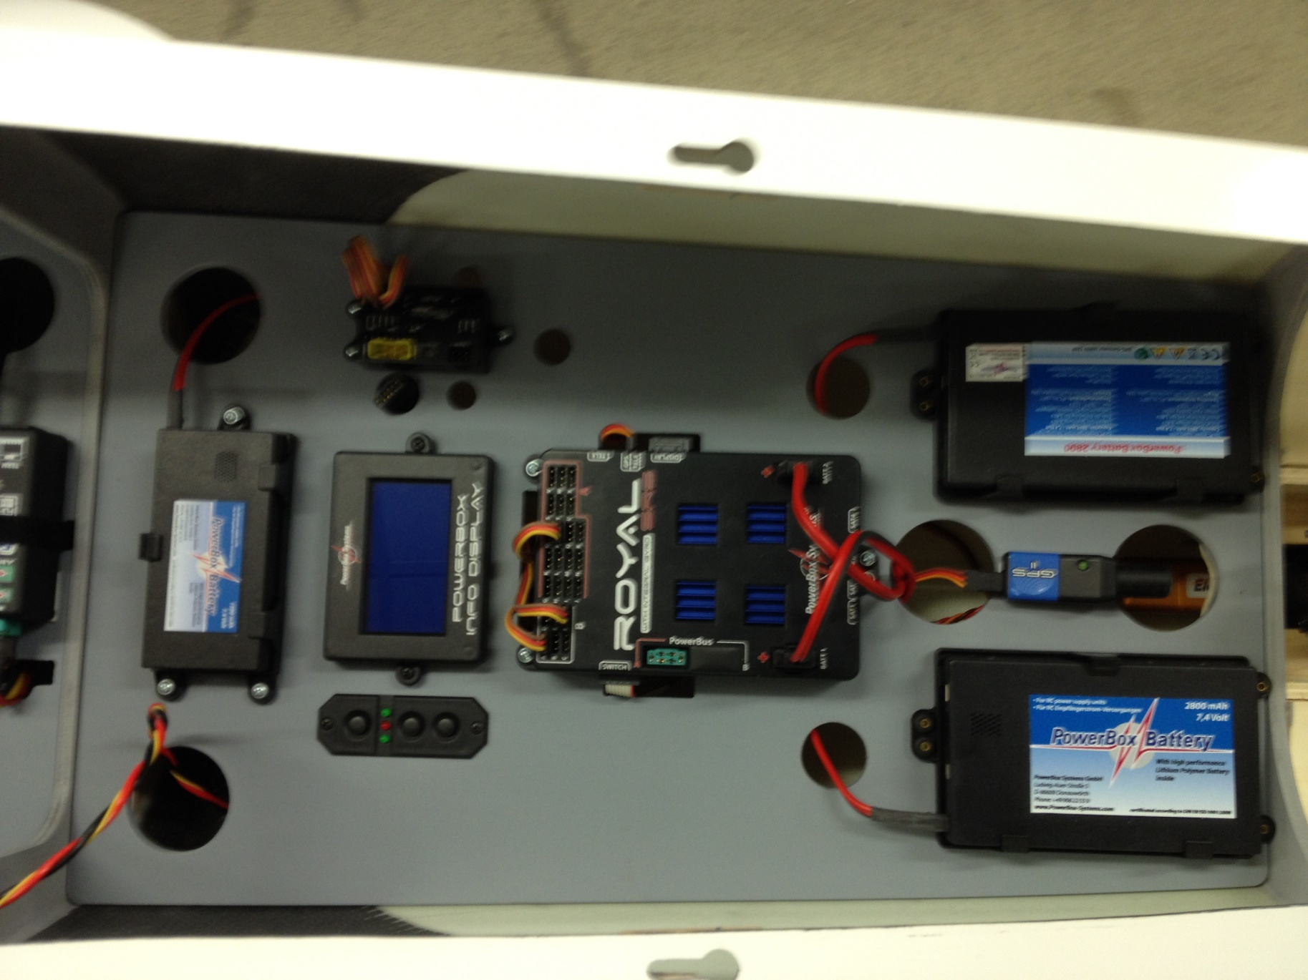

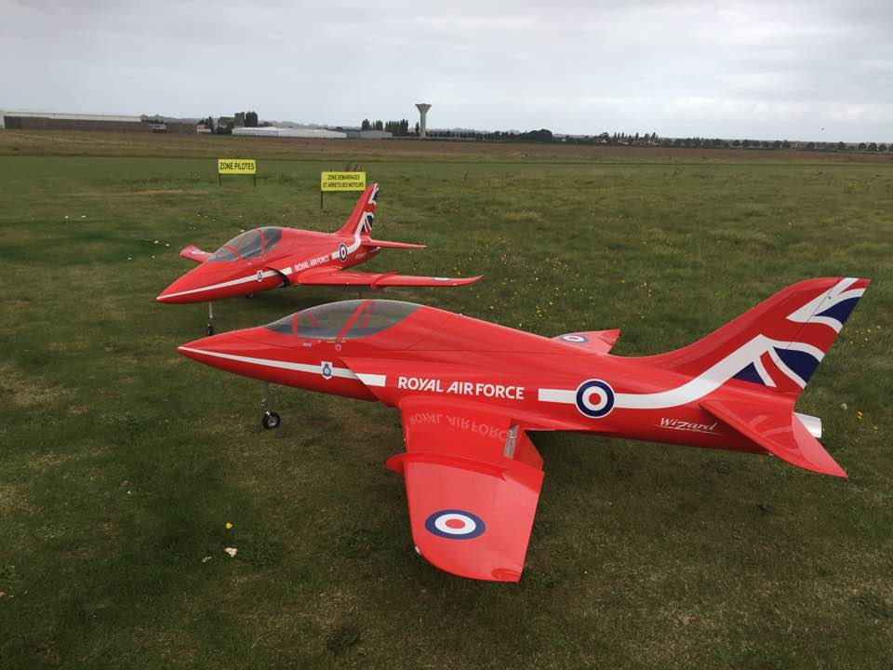

WE RECOMMAND

SERVOS :

AILERONS,ELEVATOR,RUDDER : 20kgs

FLAPS: 30kgs

TURBINE:

20-25N

POWERBOX SYSTEM:

MERCURY
ROYAL
Or
SIMILAR

